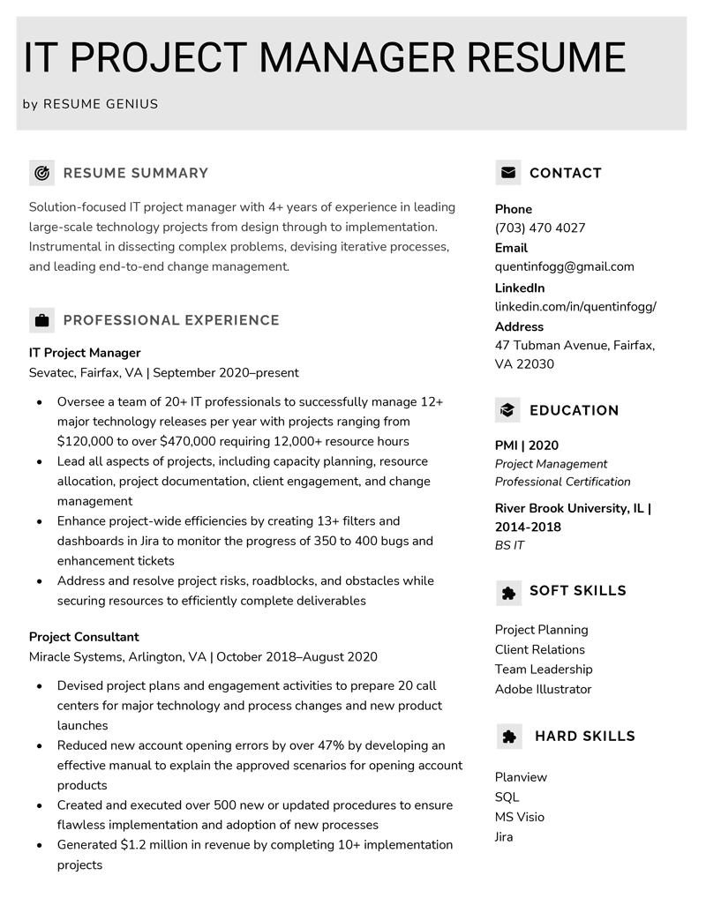
IT PROJECT MANAGER RESUME
by RESUME GENIUS
RESUME SUMMARY
Solution-focused IT project manager with 4+ years of experience in leading large-scale technology projects from design through to implementation. Instrumental in dissecting complex problems, devising iterative processes, and leading end-to-end change management.
PROFESSIONAL EXPERIENCE
IT Project Manager
Sevatec, Fairfax, VA | September 2020-present
Oversee a team of 20+ IT professionals to successfully manage 12+ major technology releases per year with projects ranging from $120,000 to over $470,000 requiring 12,000+ resource hours Lead all aspects of projects, including capacity planning, resource allocation, project documentation, client engagement, and change management
Enhance project-wide efficiencies by creating 13+ filters and
dashboards in Jira to monitor the progress of 350 to 400 bugs and enhancement tickets
• Address and resolve project risks, roadblocks, and obstacles while securing resources to efficiently complete deliverables
Project Consultant
Miracle Systems, Arlington, VA | October 2018-August 2020
• Devised project plans and engagement activities to prepare 20 call
centers for major technology and process changes and new product launches
Reduced new account opening errors by over 47% by developing an effective manual to explain the approved scenarios for opening account products
• Created and executed over 500 new or updated procedures to ensure flawless implementation and adoption of new processes Generated $1.2 million in revenue by completing 10+ implementation projects
Phone
CONTACT
(703) 470 4027
Email
quentinfogg@gmail.com
LinkedIn
linkedin.com/in/quentinfogg/
Address
47 Tubman Avenue, Fairfax, VA 22030
EDUCATION
PMI | 2020
Project Management Professional Certification
River Brook University, IL | 2014-2018
BS IT
SOFT SKILLS
Project Planning Client Relations
Team Leadership Adobe Illustrator
HARD SKILLS
Planview
SQL
MS Visio Jira

